**Project summary:**

This application is designed to visually track and display locations of Tweets, based on a given search term, in a customized Google Map frame. The location of Tweets will be determined by the location attribute received from the Twitter API for any given Tweet. Additionally, the application will show a live stream of tweets and real time analytics of the data – such as grouping by country, continent, etc.

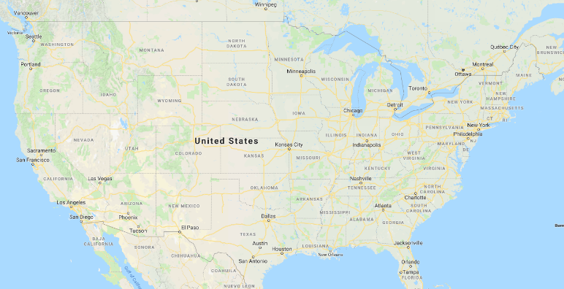

Live Twitter Stream (limited to show the latest 5-10 tweets that contain a specific search term from the search box above)

Search term… (e.g. “javascript”)







Analytics

Charts/graphs to further analyze the data

**List of dependencies:**

|  |  |
| --- | --- |
| Server | Client |
| Express | Redux |
| Socket.io | Socket.io |
| twitter-stream-api | react-google-maps |
| Firebase | Boostrap 4 |
| NodeJS | react-chartjs |

**List of tasks**:

* Build folder structure for both server and client
* Create general layout and flex boxes for the content
* Create API keys and tokens for Google Maps and Twitter APIs
* Customize the Google map layout and define custom location pointers
* Define Redux data store and make it available across components
* Implement websocket connections
* Build component to handle real time analytics of the data
* Test the application

**Plan for the next 3 weeks:**

|  |  |  |
| --- | --- | --- |
| Week 1 | Week 2 | Week 3 |
| Build basic layout of the app | Implement twitter stream logic | Test |
| Obtain API keys and tokens | Build analytics section | Deploy to firebase |
| Apply basic bootstrap design |  |  |
| Implement websockets |  |  |
| Incorporate Google Maps |  |  |
|  |  |  |